GROUP ID: A679210
GROUP NAME: 1976 TFGH
GROUP AGENT: Joseph Konecek (480) 324 -5606

DATES: October 6th – 13th, 2018

ITINERARY: 7 Day Hawaii, Roundtrip from Honolulu

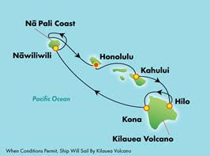

DEPOSIT: $250 per person

FINAL PAYMENT: Due 7/8/2018 (Deposit fully refundable until this date)

FREE GROUP AMENITIES: (Pick Two Per Cabin)

  - Pre-Paid Service Charges (Guest 1 & 2) Value: $195.86
  - 250 Minute Wifi Package Value: $125
  - 4 Night Specialty Dining Package, Incl. 18% Gratuity (Guest 1 & 2) Value: $240+
  - $75 On Board Credit
  - $50 per port Shore Excursion Credit Value: $200
  - 20 Photograph Package Value: $195

AVAILABLE STATEROOMS:

We are holding a limited amount of the following cabin types for your group, rates will be held for up for limited time. Lower prices may be available in other categories for those that book early!

INSIDE (CAT IB): $1,709 + tax USD per person (based on double occupancy) DECK 10 or 11
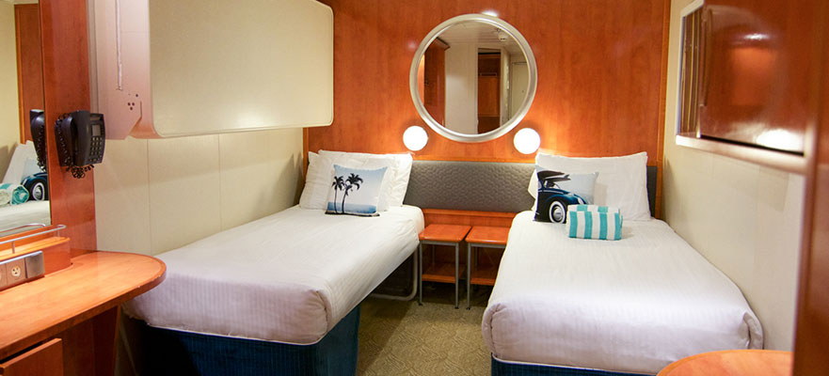

MID-SHIP INSIDE (CAT IA): $1,719 + tax USD per person (based on double occupancy) DECK 4

OCEAN VIEW(CAT OA): $1,919 + tax USD per person (based on double occupancy)
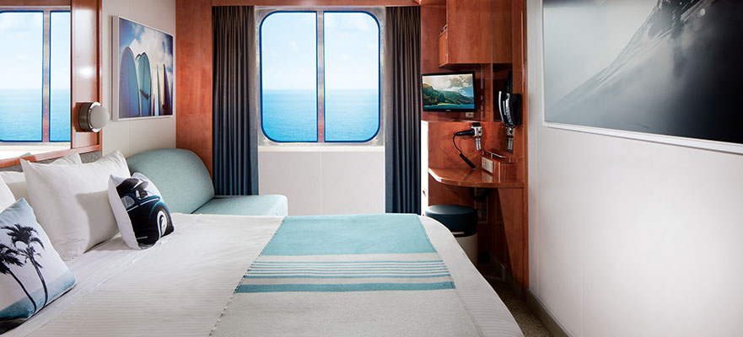

BALCONY (CAT BD): $2,199 + tax USD per person (based on double occupancy)
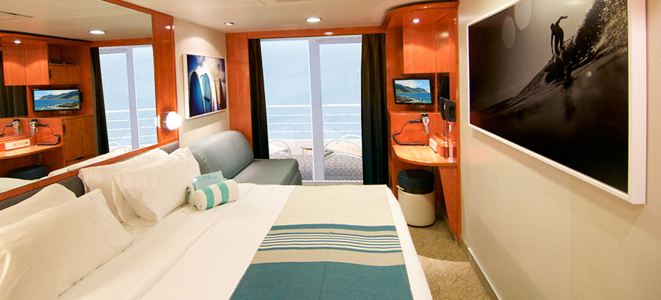

NEED TO KNOW:

- After the reservation is set up future payments can be made online by creating an account at: https://www.ncl.com/register This site is also useful for booking Shore Excursions, Diner Reservations, and completing the Online Check-In prior to sailing.

- Guests who require cabins for 3 or more passengers are encouraged to make a deposit sooner than later. Cabins with these accommodations are very limited and are on a first come basis. Please call for a price quote on additional passengers.

- Daily gratuity of $13.99pp is not included in below pricing. Guests may pre-pay anytime before boarding or pay prevailing rate on board.

- Questions about Travel Documentation visit: http://www.ncl.com/about/required-travel-documentation

- Travel Insurance is recommended but not required. For information about coverage visit: http://www.ncl.com/freestyle-cruise/booksafe

- Interested in a price quote for a room category not listed below? Call or email for a quote.

To explore the ship online visit: https://www.ncl.com/cruise-ship/pride-of-america

